**Impact of Climate Change on Food Security**

Anmol Negi, Deepti Rathi, Jayant Maini, Vineeta Sharma and Preeti Nandal*

Department of Biotechnology, School of Engineering and Technology, Manav Rachna International Institute of Research and Studies (MRIIRS), Faridabad, Haryana, India.

*Corresponding Author: Preeti Nandal

Correspondence at [preetinandal.set@mriu.edu.in](mailto:vineeta.set@mriu.edu.in) or [preetinandal@gmail.com](mailto:preetinandal@gmail.com)

**Abstract**

The ever-increasing population poses a major threat to the feeding of billions which in turn challenges food security. In the present scenario, a third of all food produced (~2.5 billion tonnes) is wasted annually. Whereas 20-40% of the annual Global Crop yield is lost due to plant pathogens. Thus, exacerbating food security. Climate change is promoting the growth of these spoilage microorganisms. These plant pathogens respond to changing climate in three keyways- multiplication (increased reproduction), migration (to new location/ host jumping) and evolution (genetic trait alteration and speciation). Therefore, it is the need of the hour to identify ways to reduce the yield loss caused by the microbes that turn pathogenic as a result of climate change. The main goals of this study are to gather information about the relationship between pathogens growth and climate change, summarize the information, and develop a regression model using multiple variables to forecast how climate change will affect growth of these pathogens, then crop yield and finally the prices of food products in the market. This prediction model can help farmers and farming businesses to predict crop yield in a particular season, knowing the cultivation and harvest time of a particular crop in order to generate a high yield crop.

**Keywords:** Climate change, Food security, plant pathogens, migration, host jumping, genetic trait, evolution, prediction model

**Introduction**

The climate is referred to as the weather conditions over a large area for an extended period of time (Verma et al 2023). Whereas climate change is known as the change in climate related to human activities directly or indirectly and that supasses the natural climate changes that has been reported within comparable time frames (UNFCC 2011). The key physical parameters such as temperature, precipitation, and humidity are taken into consideration for variation in weather as well as climate (Verma et al 2023). The Intergovernmental Panel Climate Change (IPCC) has classified climate change scenarios for future climate prediction into synthetic (incremental), analog, and climate model-based scenarios (Santoso and Idinoba 2008). The synthetic scenarios can be created using a tool that adds random values to the realistic baseline data to regulate precipitation and temperature for climate conditions in the future. Whereas, analog scenarios analyzed historical climatic data on a temporal basis to generate possible future analog climatic conditions. However, model-based scenarios can be produced by baseline corrections in the data after comparing or analysing historical and future extracted model data sets (Santoso and Idinoba 2008). Natural changes or anthropogenic activities can be the primary reason for the variations in the climate. Majorly, atmospheric activities like urbanization, industrialization, pollution, deforestation, change in land use patterns, and agricultural activities contribute to rising atmospheric concentrations of water vapor, carbon dioxide (CO2), and other greenhouse gases (GHGs) such as nitrous oxide (N2O), methane (CH4), sulfur hexafluoride (SF6), hydrofluorocarbons, perfluorocarbons. All these gases lead to accelerating the Earth’s atmospheric temperature and causing further increases in the rate of climate change (Pati et al 2017, Mohapatra et al 2017, Wijerathna-Yapa and Pathirana 2022). Thus, climate change directly impacts biodiversity, soil, water shortages, and food insecurity to feed an increasing population (Farooq et al 2023). Therefore, climate change is a major risk to the ecosystem ( Wijerathna-Yapa and Pathirana 2022).

Soils are important for supporting plant life, storing energy in the form of carbon, and buffering the climate. Rise in temperature causes more evapotranspiration and reduces rainfall to maintain soil moisture, resulting in more dust storms, desertification, and salinization of croplands. Moreover, the temperature rise has a plausible effect on nutrient levels and structure of soil by fasting the rate of microbial decomposition and nutrient cycling. Additionally, soil moisture levels got reduced, leading to soil erosion and reduced soil health (Furtak and Wolinskan 2023). Thus challenging plants to uptake nutrients from the soil for their growth (Wijerathna-Yapa and Pathirana 2022). Therefore significantly affects the planet’s soils and water, which in turn impacts food production (Fadiji et al 2023).

The effects of change have been observed in the agricultural sector in food crops (IPCC 2021). Not only the soil quality, interactions among soil microbes and the plants have also been greatly influenced by the change in climate resulting in, crops facing water shortages, reduced growth, and low yield due to climate variations. Therefore, the financial burden to the farmers, country, and leading to a shrink in food security and significantly impacting agri-food systems (Farooq et al 2023). According to IPCC’s 6th Assessment Report on Climate Change, ten percent of the currently available area for agriculture is anticipated to be unfit by 2050 under high-emission scenarios (SSPs) (IPCC 2021). Unfortunately, climate change reduces the nutritive value of the crops due to their exposure to CO2 at the predictive level of 2050, where plants lose their zinc, iron, and proteins by 10, 5, and 8 percent respectively. Thus causing another threat to the world address malnutrition (Adhikari et al 2015 and Nelson et al 2018).

The primary cereal crops such as wheat, rice, and corn are consumed globally as staple foods by the majority of the population (FAO 2015). Due to the drastic increase in the world’s population and environmental sustainability concerns, meeting the food demand of the growing population is a global concern (Noya et al 2018, Godfray et al 2010).

Climate change significantly affects agriculture due to rise in temperature, low rainfall, high CO2 level, variation in crop growing season, pest infestation, soil loss, sea level, etc. Microorganisms play an important role in nutrient cycling by decomposition of organic matter into minerals that can be easily uptake by plants (Singh et al 2019). Plants responses to environmental changes by changing their biology that includes their phenology, sugar, starch, nitrogen and phenolic contents. Not only changes in stomatal densities, conductance, root and shoot biomass, number and size of leaves also affected along with changes in gene expression (Elad and Pertot 2014). Along with the plants, microorganisms also are affected by climate change. Being a backbone of ecosystem, microbes play important role in biogeochemical cycle, plant health and food web globally (Khan et al 2012). Zhou et al 2016 and Ibáñe et al 2023, reported that with increase in temperature, microbial growth rate, microbial metabolism and number of species increasing drastically. Rise in temperature causing more release of CO2 due to decomposition by microbes. Change in precipitation due to climate change has been observed which resulted in acidic soil conditions that affected the habitat of microbes [Singh et al 2019 and Li et al 2018]. Overall, climate change is a threat to all living forms, balance in the nature and majorly affecting plants and dependancy of human population on plant crops as world’s 70% low-income population is relying on agricultural and natural resources for their livelihood, thus climate change hitting the poor nation hardest (Farooq et al 2023).

In this work, we are studying the impact of climate change on cereal or food crops due to the changes in the behaviour of microflora of the soil which actually changes with the change in the climate.

**2. Methodology**

#### 2.1 Data Extraction

The primary data for this research was sourced from a comprehensive resource article available in PDF format(Ayalew, T. and Worku, W. (2019)). The article detailed the impacts of various temperature conditions on different plant pathogens and their subsequent effect on food yield. The data extraction process involved the following steps:

1. PDF Review: The resource article was thoroughly reviewed to identify relevant data points. This included information on different pathogens, the temperature conditions they thrive in, and their impact on food yield.
2. Data Extraction: Relevant data was manually extracted from the PDF document. This involved noting down specific details such as the pathogen names, temperature conditions affecting them, and the corresponding impact on food yield.
3. CSV File Creation: The extracted data was organized into a structured format using a spreadsheet application. Each row represented a unique pathogen, with columns for the pathogen name, temperature condition, and impact on food yield. The structured data was then saved as a CSV file for further analysis().

#### 2.2 Data Visualization

To visualize the extracted data and derive meaningful insights, various graphs and plots were created using Python programming language, specifically utilizing the Pandas, Matplotlib, and Seaborn libraries. The following steps were undertaken:

1. Loading Data: The CSV file was loaded into a Pandas Dataframe for easy manipulation and analysis.
2. Initial Plotting:
   * Bar Plot for Temperature Effects: A bar plot was created to show how different temperature conditions affect various pathogens. This was achieved using Matplotlib, where the x-axis represented the pathogens, and the y-axis represented the temperature conditions.
   * Bar Plot for Impact on Food Yield: Another bar plot was created to illustrate the impact of different pathogens on food yield under varying temperature conditions. The x-axis displayed the pathogens, while the y-axis showed the impact on food yield.
3. Scatter Plot for Combined Analysis:
   * Scatter Plot Creation: A scatter plot was created to analyze the combined effect of temperature conditions on pathogens and their impact on food yield. Seaborn was used for this visualization due to its enhanced capabilities for creating detailed scatter plots.
   * Customization: The scatter plot was customized to include different colors for each pathogen, providing a clear visual distinction. The x-axis represented temperature conditions, while the y-axis represented the impact on food yield.
4. Graph Interpretation: The created graphs were analyzed to interpret the data effectively. Observations were made regarding which pathogens are most affected by specific temperature conditions and how these conditions influence food yield.

#### 2.3 Software and Tools

* Python: Used for data analysis and visualization.
* Pandas: For data manipulation and handling CSV files.
* Matplotlib: For creating bar plots.
* Seaborn: For creating detailed scatter plots.
* Spreadsheet Application: For organizing extracted data into a CSV file.

**Result And Discussion**

After required analysis, the visual representation of relevant information was carried out.(Ayalew, T. and Worku, W. (2019).)

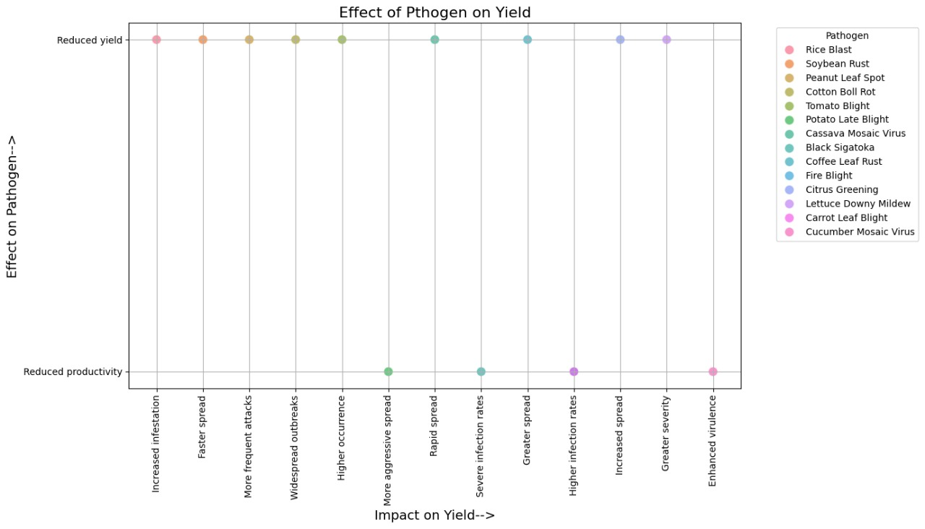

Figure 1. The graph visualizes the relationship between different pathogens and their effects on agricultural yield and productivity.

In this graph **X-Axis** represents the "Impact on Yield" whereas **Y-Axis** represents the "Effect on Pathogen".

Each point on the graph represents a specific pathogen and its impact on crop yield and productivity. The different colors correspond to different pathogens, as indicated in the legend on the right.

#### Legend (Pathogens):

* Red: Rice Blast
* Orange: Soybean Rust
* Light Green: Peanut Leaf Spot
* Green: Cotton Boll Rot
* Lime: Tomato Blight
* Olive: Potato Late Blight
* Light Blue: Cassava Mosaic Virus
* Blue: Black Sigatoka
* Teal: Coffee Leaf Rust
* Cyan: Fire Blight
* Dark Blue: Citrus Greening
* Dark Purple: Lettuce Downy Mildew
* Light Purple: Carrot Leaf Blight
* Pink: Cucumber Mosaic Virus

This graph effectively illustrates the diverse impacts that various pathogens have on agricultural productivity and yield. Each point corresponds to a specific pathogen, showing its unique impact on the crop, helping in understanding which pathogens are more detrimental to yield and productivity.

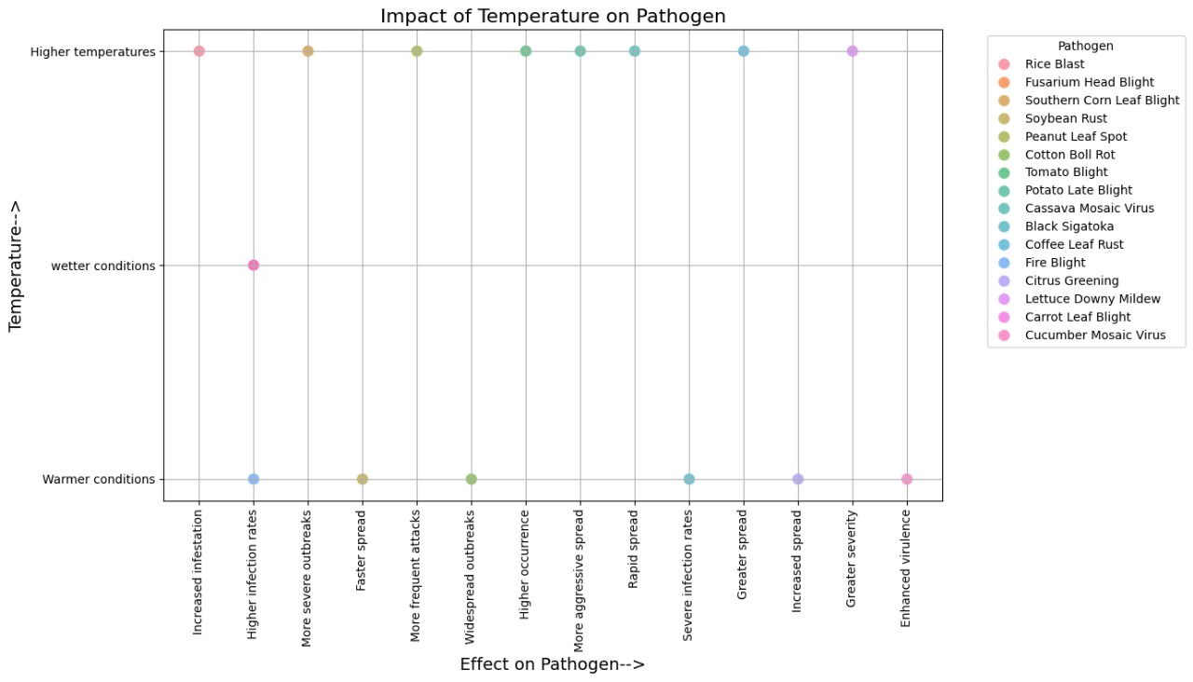Figure 2. This graph visualizes the impact of temperature on the behavior and effect of various pathogens.

In this graph **X-Axis** represents the "Effect on Pathogen", **Y-Axis** represents "Temperature".

Each point on the graph represents a specific pathogen and its behavior under different temperature conditions.

### Key Points:

* **Higher temperatures**: Pathogens that are more active or spread more aggressively under higher temperature conditions.
* **Wetter conditions**: Pathogens that thrive in moist environments, leading to more severe or widespread outbreaks.
* **Warmer conditions**: Pathogens that exhibit increased activity, spread, or virulence in warmer climates.

This graph provides a comprehensive overview of how different pathogens react to varying temperature conditions, from higher temperatures to wetter and warmer conditions. Each point on the graph shows the specific effect a pathogen has under these conditions, allowing for an understanding of which pathogens become more problematic with temperature changes. This visualization helps in predicting and managing the impact of temperature on crop diseases.

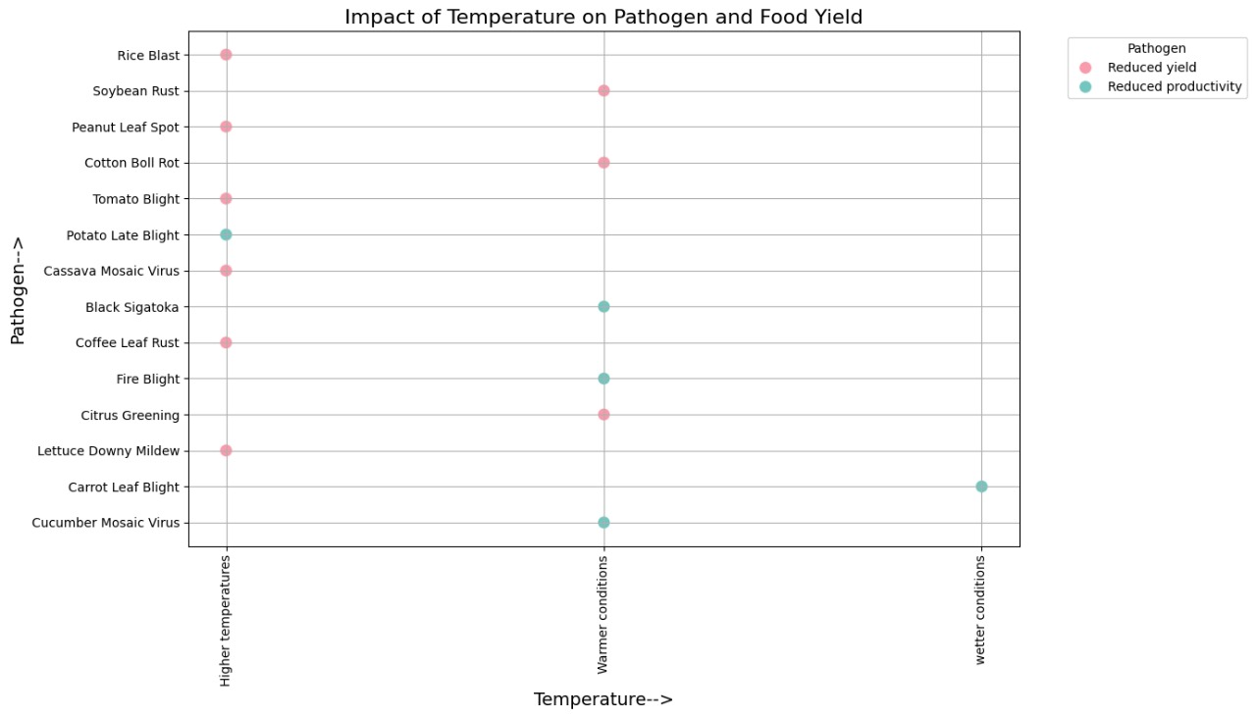

Figure 3. The graph depicts the impact of temperature on various pathogens and their effect on food yield.

In this graph X-axis indicates how varying temperature conditions influence the pathogens affecting the crops. whereas the Y axis indicates different pathogens.

### Data Points:

* **Red (Pink) Dots**: Represent the impact of pathogens under the given temperature condition that leads to **reduced yield**.
* **Green Dots**: Represent the impact of pathogens under the given temperature condition that leads to **reduced productivity**.
* **Higher Temperatures**:
  + **Rice Blast**: Higher temperatures increase rice blast infestation, leading to reduced yield (pink dot).
  + **Peanut Leaf Spot**: More frequent attacks under higher temperatures, leading to reduced yield (pink dot).
  + **Tomato Blight**: Higher occurrence under higher temperatures, leading to reduced yield (pink dot).
  + **Coffee Leaf Rust**: Increased infestation under higher temperatures, leading to reduced yield (pink dot).
  + **Lettuce Downy Mildew**: Increased occurrence under higher temperatures, leading to reduced yield (pink dot).
* **Warmer Conditions**:
  + **Soybean Rust**: Faster spread under warmer conditions, leading to reduced yield (pink dot).
  + **Cotton Boll Rot**: Widespread outbreaks under warmer conditions, leading to reduced yield (pink dot).
  + **Potato Late Blight**: Increased disease incidence under warmer conditions, leading to reduced productivity (green dot).
  + **Black Sigatoka**: More severe attacks under warmer conditions, leading to reduced productivity (green dot).
  + **Fire Blight**: Increased incidence under warmer conditions, leading to reduced yield (pink dot).
* **Wetter Conditions**:
  + **Potato Late Blight**: Increased disease incidence under wetter conditions, leading to reduced productivity (green dot).
  + **Cassava Mosaic Virus**: Increased severity under wetter conditions, leading to reduced productivity (green dot).
  + **Citrus Greening**: Increased incidence under wetter conditions, leading to reduced yield (pink dot).
  + **Carrot Leaf Blight**: Higher severity under wetter conditions, leading to reduced yield (pink dot).
  + **Cucumber Mosaic Virus**: Increased severity under wetter conditions, leading to reduced productivity (green dot).

### Overall Interpretation:

* The graph illustrates how different temperature conditions (higher temperatures, warmer conditions, and wetter conditions) influence the activity of various pathogens.
* The red (pink) dots indicate cases where these conditions lead to reduced yield of crops due to increased pathogen activity.
* The green dots indicate cases where these conditions lead to reduced productivity of crops due to increased pathogen activity.

This visualization helps understand the complex relationships between climate conditions, pathogen behavior, and their impacts on crop yield and productivity.

#### 4. Conclusion

By extracting and visualizing the data from the resource article, this study provides a clear understanding of the relationship between temperature conditions, pathogen activity, and food yield. The methodology outlined ensures a systematic approach to data extraction, organization, and analysis, enabling the derivation of meaningful insights that can aid in agricultural planning and management. The visual representations, particularly the scatter plot, offer a comprehensive overview of how different pathogens respond to varying temperature conditions and their subsequent impact on crop productivity.

**5. Reference**

1. Verma, B., Porwal, M., Agrawal, K. K., Behera, K., Vyshnavi, R. G., & Nagar, A. K. (2023). Addressing challenges of Indian agriculture with climate smart agriculture practices. *Emrg. Trnd. Clim. Chng*, *2*(1), 11-26.
2. UNFCCC (2011). NAPA Priorities Database. United Nations Framework Convention on Climate Change, Bonn, Germany, unfccc.int/cooperation_support/least_d eveloped_countries_portal/napa_priori ties_database/item /4583.php.
3. Santoso, H.; Idinoba, M.; Imbach, P. Climate Scenarios: What We Need to Know and How to Generate Them; CIFOR: Bogor, Indonesia, 2008; p. 45.
4. Pati, S.; Rubina, K.; Kundu, D.; Pal, B.; Saha, B.; Hazra, G.C. Impact of Global Climate Change on Agriculture. In Indian Farmer; 2017; 4, pp. 363–367. Available online: http://krishi.icar.gov.in/jspui/handle/123456789/33251 (accessed on 23 August 2021).
5. Mohapatra, U.; Sahoo, T.R.; Sethi, D. Impact of Climate Change on Agriculture in India. Rashtriya Krishi 2017, 12, 4–8.
6. Wijerathna-Yapa, A., & Pathirana, R. (2022). Sustainable Agro-Food Systems for Addressing Climate Change and Food Security. Agriculture, 12(10), 1554.
7. Farooq, A., Farooq, N., Akbar, H., Hassan, Z. U., & Gheewala, S. H. (2023). A critical review of climate change impact at a global scale on cereal crop production. *Agronomy*, *13*(1), 162.
8. Furtak, K., & Wolińska, A. (2023). The impact of extreme weather events as a consequence of climate change on the soil moisture and on the quality of the soil environment and agriculture–A review. Catena, 231, 107378.
9. Fadiji, A. E., Yadav, A. N., Santoyo, G., & Babalola, O. O. (2023). Understanding the plant-microbe interactions in environments exposed to abiotic stresses: An overview. Microbiological Research, 271, 127368.
10. IPCC. Climate Change 2021: The Physical Science Basis Working Group I Contribution to the Sixth Assessment Report of the Intergovern mental Panel on Climate Change, 6th ed.; Cambridge University Press: Cambridge, UK; New York, NY, USA, 2021.
11. Adhikari, U.; Nejadhashemi, A.P.; Woznicki, S.A. Climate Change and Eastern Africa: A Review of Impact on Major Crops. Food Energy Secur. 2015, 4, 110–132.
12. Nelson, G.; Bogard, J.; Lividini, K.; Arsenault, J.; Riley, M.; Sulser, T.B.; Mason-D’Croz, D.; Power, B.; Gustafson, D.; Herrero, M. Income Growth and Climate Change Effects on Global Nutrition Security to Mid-Century. Nat. Sustain. 2018, 1, 773–781.
13. FAO.Climate Change and Food Security: Risks and Responses. Rome, Italy. 2015. Available online: https://www.fao.org/3/i518 8e/i5188e.pdf (accessed on 14 November 2022).
14. Noya, I.; González-García, S.; Bacenetti, J.; Fiala, M.; Moreira, M.T. Environmental impacts of the cultivation-phase associated with agricultural crops for feed production. J. Clean. Prod. 2018, 172, 3721–3733. [CrossRef]
15. Godfray, H.C.J.; Beddington, J.R.; Crute, I.R.; Haddad, L.; Lawrence, D.; Muir, J.F.; Pretty, J.; Robinson, S.; Thomas, S.M.; Toulmin, C. Food security: The challenge of feeding 9 billion people. Science 2010, 327, 812–818.
16. Singh, D. P., Gupta, V. K., & Prabha, R. (Eds.). (2019). *Microbial interventions in agriculture and environment: Volume 2: Rhizosphere, microbiome and agro-ecology*. Springer Nature.
17. Elad, Y., & Pertot, I. (2014). Climate change impacts on plant pathogens and plant diseases. *Journal of Crop Improvement*, *28*(1), 99-139.
18. Khan, I., Khan, F., Ahmad, S., Pandey, P., & Khan, M. M. (2021). Microbes and Climate: A Tangled Relation. *Microbiomes and the Global Climate Change*, 3-15.
19. Zhou,J.;Deng,Y.; Shen, L.; Wen, C.; Yan, Q.; Ning, D.; Qin, Y.; Xue, K.; Wu, L.; He, Z.; etal. Temperature mediates continental-scale diversity of microbes in forest soils. Nat. Commun. 2016, 7, 12083.
20. Ibáñez, A., Garrido-Chamorro, S., & Barreiro, C. (2023). Microorganisms and climate change: a not so invisible effect. *Microbiology Research*, *14*(3), 918-947.
21. Li, G., Kim, S., Han, S. H., Chang, H., Du, D., & Son, Y. (2018). Precipitation affects soil microbial and extracellular enzymatic responses to warming. *Soil biology and biochemistry*, *120*, 212-221.
22. Ayalew, T. and Worku, W. (2019). Climate change effect on crops performance with a focus on cereals: A review. African Journal of Environmnetal Science and Technology, 13 (11).